BUSINESS STUDIES
GRADE 10
TERM 2: INFORMAL TASK
CONTEMPORARY SOCIO-ECONOMIC ISSUES
2020
WEEK 11 & 12 : 31 March to 9 April 2020
QUESTION 1
Read the scenario below and answer the questions that follow.
JAEN MANUCTURES ( JM)
Jaen Manufactures has employed 30 workers who are responsible for the manufacturing of men’s winter clothes. Highly skilled workers earned better salaries than others. Their standard of living is even better than other workers.

Some workers stay absent from work due a disease that is transferred from one infected person to another healthy person. Unskilled workers have decided to join illegal money making investment with the hope of obtaining money to improve their lifestyles. Some workers refuse to work until they are paid better salaries. JM‘s stock was stolen at night when they were not open for business.

1.1.1 Identify FIVE socio economic issues from the scenario above. Motivate your answer by quoting from the scenario.
Use the table below to present your answer.
Socio economic issue | Motivation
1)
2)
3)
4)
5)
(15)
1.1.2 Discuss ONE impact of each of the socio-economic issue identified in QUESTION1.1.1.on businesses (10)

1.1.3 Explain the meaning of the following concepts:
(a) Copyright (2)
(b) Patent (2)
(c) Trade marks (2)
1.1.4 Name a socio economic issue that can be addressed by the above mentioned concepts in QUESTION 1.1.3. (2)

BUSINESS STUDIES
GRADE 10
TERM 2: INFORMAL TASK
SOCIAL RESPONSIBILITY
WEEK 13: 14-17 April 2020
QUESTION 2
2.1 Study the cartoon below and answer the questions that follow:
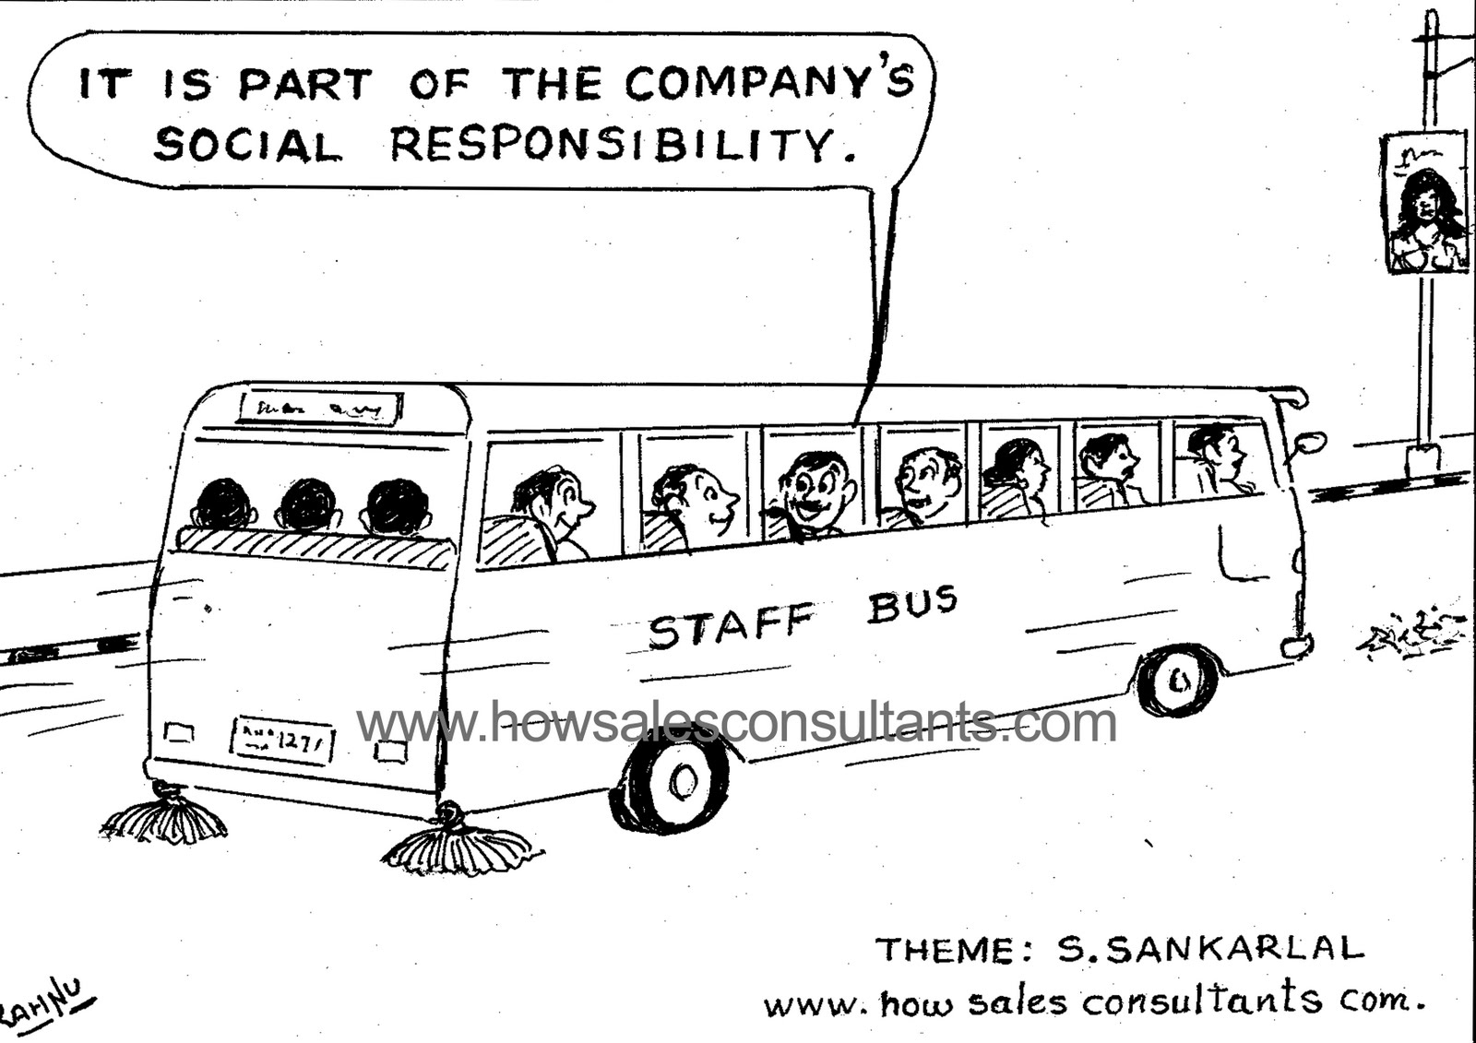

2.1.1 Explain the meaning of social responsibility (2)
2.1.2 Name the social responsibility that is depicted by the cartoon above. (2)
2.1.3 Suggest ONE initiative that can be undertaken by businesses to address EACH of the socio-economic issues discussed in ACTIVITY 1.1.1
Use the table below to present your answer:
SOCIO-ECONOMIC ISSUE | BUSINESS INITIATIVE
(1)
(2)
(3)
(4)
(8)
2.1.4 Define the concept Corporate Social Responsibility (CSR) (2)

BUSINESS STUDIES
GRADE 10
TERM 2: INFORMAL TASK
Entrepreneurial qualities
WEEK 14: 20-24 APRIL

QUESTION 3
3.1 Identify the entrepreneurial quality represented by Maggie in each statement below:
(a) Maggie attends training courses on how to expand her business.
(b) She has just established another branch even though she is not sure if the new business will be successful.
(c) Maggie’s business is not making enough profit anymore but she refuses to give up.
(d) She admits rendering poor services to her customers but promised them to improve on this.
(e) Maggie opens her business at 6am and closes at 9pm in order to cater for customers who arrive home late from work.
(f) She keeps on changing the way she does business in order to achieve her goals.
(g) Maggie always advises her workers to treat customers with respect and dignity.
(14)
3.2 Discuss FOUR other entrepreneurial qualities. (12)

BUSINESS STUDIES
GRADE 10
TERM 2: INFORMAL TASK
FORMS OF OWNERSHIP
WEEK: 15 & 17: 25 -29 May
QUESTION 4
4.1 Outline factors that an entrepreneur must consider when choosing a form of ownership (6)
4.2 Study the pictures below and answer the questions that follow.

PICTURE A Picture B

PICTURE C PICTURE D

.4.2.1 Identify the form of ownership represented by each picture above. Motivate your answer by quoting from the above pictures.
Use the table below to present your answer
PICTURES | FORM OF OWNERSHIP | MOTIVATION
Picture A
Picture B
Picture C
Picture D
(12)
4.2.2 Distinguish between the form of ownership depicted by Picture C and Picture D identified in QUESTION 4.2.1. (8)
4.2.3 Explain the advantages of the form of ownership represented by picture A identified in QUESTION 4.2.1. (4)
4.3 Read the scenario below and answer the questions that follow.
SIMPHIWE & MMABATHO IT CONSULTANTS (SMC)
Simphiwe and Mmabatho want to establish an Information Technology Consultants business and name it Simphiwe & Mmabatho IT Consultants. They are mindful of the fact that they will be jointly and severally liable for the debts of the business. They agreed that each of them will contribute capital, skills and knowledge to the establishment of the business. In return, they all share the profits and losses of the business.

4.3.1 Identify the form of ownership that is applicable to S&M. (2)
4.3.2 Quote THREE characteristics of the form of ownership identified in QUESTION 4.3.1 from the scenario above. (3)
4.3.3 Discuss the advantages of the form of ownership identified in QUESTION 4.3.1. (6)
4.3.4 Suppose Simphiwe wanted to start his own business without paying double tax. Name the form of ownership that will be suitable for Simphiwe and justify your answer. (3)
4.3.5 Advise Simphiwe on the impact of the form of ownership identified in QUESTION 4.3.4. (8)

